COMPUTER NETWORKS

BASIC COMMANDS:
C:\>arp–a
: ARP is short form of address resolution protocol, It will show the IP address of your computer along with the IP address and MAC address of your router.

C:\>hostname
:ThisisthesimplestofallTCP/IPcommands.Itsimplydisplaysthenameofyourcomputer.

C:\>ipconfig
: The ipconfig command displays information about the host (the computeryoursittingat)computerTCP/IPconfiguration.

C:\>ipconfig /all
: This command displays detailed configuration information about yourTCP/IP connection including Router, Gateway, DNS, DHCP, and type of Ethernetadapterin your system.

C:\>ipconfig /renew
: Using this command will renew all your IP addresses that you arecurrently(leasing)borrowingfromtheDHCPserver.Thiscommandisaquickproblemsolverifyouarehavingconnectionissues,butdoesnotworkifyouhavebeenconfiguredwitha staticIPaddress.

C:\>ipconifg /release
: This command allows you to drop the IP lease from the DHCPserver.

C:\>ipconfig/flushdns
:Thiscommandisonlyneededifyou’rehavingtroublewithyournetworks DNS configuration. The best time to use this command is after networkconfigurationfrustrationsetsin,andyoureally needthecomputertoreplywithflushed.

C:\>nbtstat –a
: This command helps solve problems with NetBIOS name resolution.(Nbtstandsfor NetBIOSover TCP/IP)

C:\>netdiag
: Netdiag is a network testing utility that performs a variety of network diagnostictests, allowing you to pinpoint problems in your network. Netdiag isn’t installed by default,but can be installed from the Windows XP CD after saying no to the install. Navigate to theCDROM drive letter and openthe support\toolsfolder on theXP
CDandclickthesetup.exeiconinthesupport\toolsfolder.

C:\>netstat
: Netstat displays a variety of statistics about a computers active TCP/IPconnections.Thistoolismostusefulwhenyou’rehavingtroublewithTCP/IPapplicationssuchas HTTP, and FTP.

C:\>nslookup
: Nslookup is used for diagnosing DNS problems. If you can access aresourcebyspecifyinganIPaddressbut notit’sDNSyou havea DNSproblem.
C:\>pathping:Pathping is unique to Window’s, and is basically a combination of the Ping and Tracert commands. Pathping traces the route to the destination address then launches a 25 second test of each router along the way, gathering statistics on the rate of data loss along each hop.

C:\>ping: Ping is the most basic TCP/IP command, and it’s the same as placing a phone callto your best friend. You pick up your telephone and dial a number, expecting your best friendto reply with “Hello” on the other end. Computers make phone calls to each other over a network by using a Ping command. The Ping commands main purpose is to place a phone call to another computer on the network, and request an answer. Ping has 2 options it can use to place a phone call to another computer on the network. It can use the computers name or IP address.

C:\>route: The route command displays the computers routing table. A typicalcomputer, with a single network interface, connected to a LAN, with a router is fairly simple and generally doesn’t pose any network problems. But if you’re having trouble accessing other computers on your network, you can use theroutecommandtomakesuretheentriesinthe routing table are correct.

C:\>tracert:Thetracertcommanddisplaysalistofalltheroutersthatapackethastogothroughto get fromthe computer wheretracertisrunto any othercomputer on the
internet.

LAB01: Basic client server establishment
Client:-
#include <sys/socket.h>
#include <sys/types.h>
#include <netinet/in.h>
#include <netdb.h>
#include <stdio.h>
#include <string.h>
#include <stdlib.h>
#include <unistd.h>
#include <errno.h>
#include <arpa/inet.h>

int main()
{
int CreateSocket = 0,n = 0;
char dataReceived[1024];
struct sockaddr_in ipOfServer;

memset(dataReceived, '0' ,sizeof(dataReceived));
if((CreateSocket = socket(AF_INET, SOCK_STREAM, 0))< 0)
{
printf("Socket not created \n");
return 1;
}

ipOfServer.sin_family = AF_INET;
ipOfServer.sin_port = htons(2017);
ipOfServer.sin_addr.s_addr = inet_addr("127.0.0.1");

if(connect(CreateSocket, (struct sockaddr *)&ipOfServer, sizeof(ipOfServer))<0)
{
printf("Connection failed due to port and ip problems\n");
return 1;
}

while((n = read(CreateSocket, dataReceived, sizeof(dataReceived)-1)) > 0)
{
dataReceived[n] = 0;
if(fputs(dataReceived, stdout) == EOF)
{
printf("\nStandard output error");
}

printf("\n");
}

if( n< 0)
{
printf("Standard input error \n");
}

return 0;
}
Server:-
#include <stdio.h> // standard input and output library
#include <stdlib.h> // this includes functions regarding memory allocation
#include <string.h> // contains string functions
#include <errno.h> //It defines macros for reporting and retrieving error conditions through error codes
#include <time.h> //contains various functions for manipulating date and time
#include <unistd.h> //contains various constants
#include <sys/types.h> //contains a number of basic derived types that should be used whenever appropriate
#include <arpa/inet.h> // defines in_addr structure
#include <sys/socket.h> // for socket creation
#include <netinet/in.h> //contains constants and structures needed for internet domain addresses

int main()
{
time_t clock;
char dataSending[1024]; // Actually this is called packet in Network Communication, which contain data and send through.
int clintListn = 0, clintConnt = 0;
struct sockaddr_in ipOfServer;
clintListn = socket(AF_INET, SOCK_STREAM, 0); // creating socket
memset(&ipOfServer, '0', sizeof(ipOfServer));
memset(dataSending, '0', sizeof(dataSending));
ipOfServer.sin_family = AF_INET;
ipOfServer.sin_addr.s_addr = htonl(INADDR_ANY);
ipOfServer.sin_port = htons(2017); // this is the port number of running server
bind(clintListn, (struct sockaddr*)&ipOfServer , sizeof(ipOfServer));
listen(clintListn , 20);

while(1)
{
printf("\n\nHi,Iam running server.Some Client hit me\n"); // whenever a request from client came. It will be processed here.
clintConnt = accept(clintListn, (struct sockaddr*)NULL, NULL);

clock = time(NULL);
snprintf(dataSending, sizeof(dataSending), "%.24s\r\n", ctime(&clock)); // Printing successful message
write(clintConnt, dataSending, strlen(dataSending));

close(clintConnt);
sleep(1);
}

return 0;
}
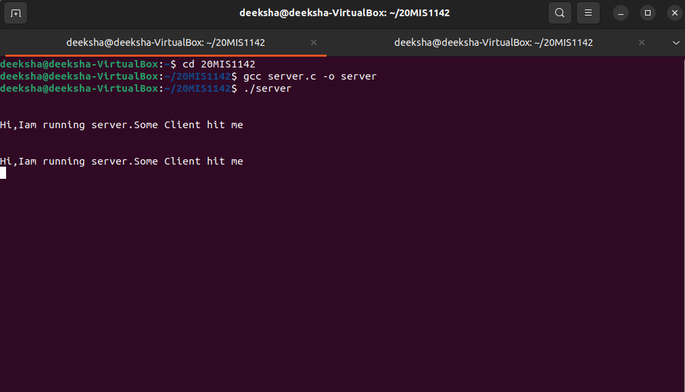
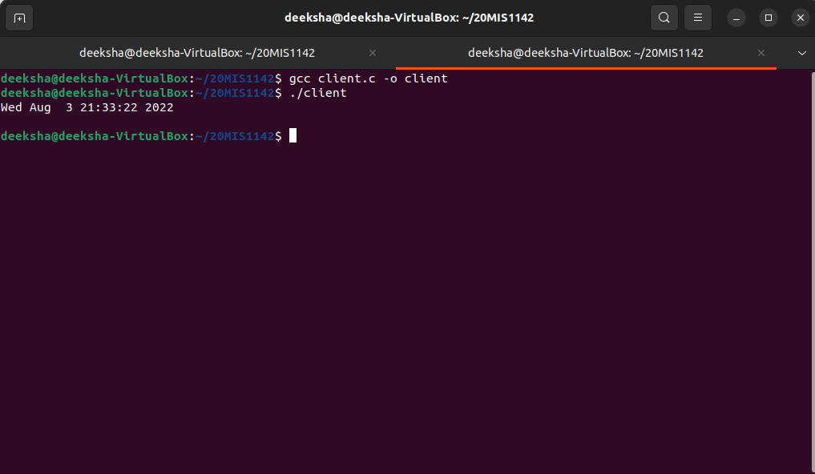

LAB02: TCP chat application
Client chat:-
#include <stdio.h>
#include <netinet/in.h>
#include <sys/types.h>
#include <sys/socket.h>
#include <netdb.h>
#include <fcntl.h> // for open
#include <unistd.h> // for close
#include <string.h>
#include <stdlib.h>
#include <arpa/inet.h>

#define MAX 80
#define PORT 43454
#define SA struct sockaddr
void func(int sockfd)
{
char buff[MAX];
int n;
for (; ;)
{
bzero(buff, sizeof(buff));
printf("Enter the string : ");
n = 0;
while ((buff[n++] = getchar()) != '\n')
;
write(sockfd, buff, sizeof(buff));
bzero(buff, sizeof(buff));
read(sockfd, buff, sizeof(buff));
printf("From Server : %s", buff);
if ((strncmp(buff, "exit", 4)) == 0)
{
printf("Client Exit...\n");
break;
}
}
}

int main()
{
int sockfd, connfd;
struct sockaddr_inservaddr, cli;
sockfd = socket(AF_INET, SOCK_STREAM, 0);
if (sockfd == -1)
{
printf("socket creation failed...\n");
exit(0);
}
else
printf("Socket successfully created..\n");
bzero(&servaddr, sizeof(servaddr));
servaddr.sin_family = AF_INET;
servaddr.sin_addr.s_addr = inet_addr("127.0.0.1");
servaddr.sin_port = htons(PORT);
if (connect(sockfd, (SA *)&servaddr, sizeof(servaddr)) != 0)
{
printf("connection with the server failed...\n");
exit(0);
}
else
printf("connected to the server..\n");
func(sockfd);
close(sockfd);
}
Server chat:-
#include <stdio.h>
#include <netinet/in.h>
#include <sys/types.h>
#include <sys/socket.h>
#include <netdb.h>
#include <stdlib.h>
#include <string.h>
#include <fcntl.h> // for open
#include <unistd.h> // for close

#define MAX 80
#define PORT 43454
#define SA struct sockaddr
void func(int sockfd)
{
char buff[MAX];
int n;
for (; ;)
{
bzero(buff, MAX);
read(sockfd, buff, sizeof(buff));
printf("From client: %s\t To client : ", buff);
bzero(buff, MAX);
n = 0;
while ((buff[n++] = getchar()) != '\n')
;
write(sockfd, buff, sizeof(buff));
if (strncmp("exit", buff, 4) == 0)
{
printf("Server Exit...\n");
break;
}
}
}
int main()
{
int sockfd, connfd, len;
struct sockaddr_inservaddr, cli;
sockfd = socket(AF_INET, SOCK_STREAM, 0);
if (sockfd == -1)
{
printf("socket creation failed...\n");
exit(0);
}
else
printf("Socket successfully created..\n");
bzero(&servaddr, sizeof(servaddr));
servaddr.sin_family = AF_INET;
servaddr.sin_addr.s_addr = htonl(INADDR_ANY);
servaddr.sin_port = htons(PORT);
if ((bind(sockfd, (SA *)&servaddr, sizeof(servaddr))) != 0)
{
printf("socket bind failed...\n");
exit(0);
}
else
printf("Socket successfully binded..\n");
if ((listen(sockfd, 5)) != 0)
{
printf("Listen failed...\n");
exit(0);
}
else
printf("Server listening..\n");
len = sizeof(cli);
connfd = accept(sockfd, (SA *)&cli, &len);
if (connfd< 0)
{
printf("server acccept failed...\n");
exit(0);
}
else
printf("server acccept the client...\n");
func(connfd);
close(sockfd);
}
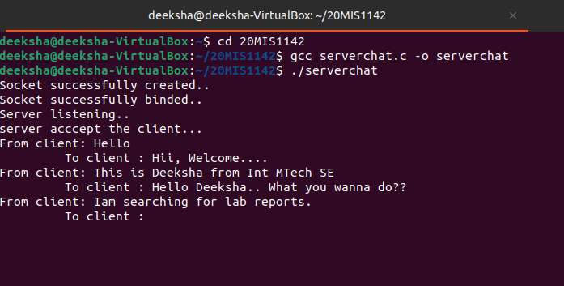
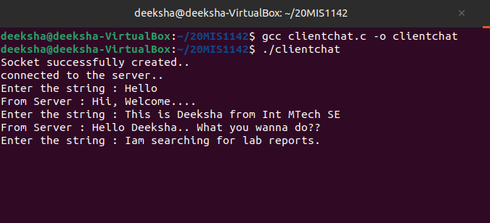

LAB03: TCP date and time
Client date:-
#include"netinet/in.h"
#include"sys/socket.h"
#include"stdio.h"
main()
{
struct sockaddr_insa,cli;
int n,sockfd;
int len;char buff[100];
sockfd=socket(AF_INET,SOCK_STREAM,0);
if(sockfd<0){printf("\nError in Socket");
exit(0);
}
else printf("\nSocket is Opened");
bzero(&sa,sizeof(sa));
sa.sin_family=AF_INET;
sa.sin_port=htons(5600);
if(connect(sockfd,(struct sockaddr*)&sa,sizeof(sa))<0)
{
printf("\nError in connection failed");
exit(0);
}
else
printf("\nconnected successfully");
if(n=read(sockfd,buff,sizeof(buff))<0)
{
printf("\nError in Reading");
exit(0);
}
else
{printf("\nMessage Read %s",buff);
}}
Server date:-
#include"netinet/in.h"
#include"sys/socket.h"#include"stdio.h"
#include"string.h"
#include"time.h"
main( )
{
struct sockaddr_insa;
struct sockaddr_incli;intsockfd,conntfd;intlen,ch;char str[100];
time_t tick;
sockfd=socket(AF_INET,SOCK_STREAM,0);
if(sockfd<0)
{
printf("error in socket\n");
exit(0);
}
else printf("Socket opened");
bzero(&sa,sizeof(sa));
sa.sin_port=htons(5600);
sa.sin_addr.s_addr=htonl(0);
if(bind(sockfd,(struct sockaddr*)&sa,sizeof(sa))<0)
{
printf("Error in binding\n");
}
else
printf("Binded Successfully");
listen(sockfd,50);
for(; ;)
{
len=sizeof(ch);
conntfd=accept(sockfd,(struct sockaddr*)&cli,&len);
printf("Accepted");
tick=time(NULL);
snprintf(str,sizeof(str),"%s",ctime(&tick));
printf("%s",str);write(conntfd,str,100);
}
}
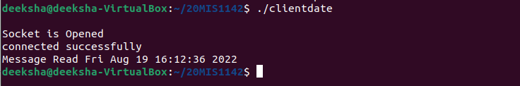

LAB04: TCP sum of random numbers
Client sum:-
#include <arpa/inet.h>
#include <stdio.h>
#include <stdlib.h>
#include <string.h>
#include <sys/socket.h>
#include <unistd.h>

#define PORT 8080

int main()
{
int sock = 0, valread, client_fd;
struct sockaddr_inserv_addr;
char* hello = malloc(sizeof(char) * 200);
char buffer[1024] = { 0 };

if ((sock = socket(AF_INET, SOCK_STREAM, 0)) < 0) {
printf("\n Socket creation error \n");
return -1;
}

serv_addr.sin_family = AF_INET;
serv_addr.sin_port = htons(PORT);

// Convert IPv4 and IPv6 addresses from text to binary
// form
if (inet_pton(AF_INET, "127.0.0.1", &serv_addr.sin_addr)
<= 0) {
printf(
"\nInvalid address/ Address not supported \n");
return -1;
}

if ((client_fd
= connect(sock, (struct sockaddr*)&serv_addr,
sizeof(serv_addr)))
< 0) {
printf("\nConnection Failed \n");
return -1;
}

printf("Connection Establishment with server was Successful!\n");

valread = read(sock, buffer, 1024);
int n1 = atoi(buffer);
printf("Server: %d\n", n1);

sleep(5);

valread = read(sock, buffer, 1024);
int n2 = atoi(buffer);
printf("Server: %d\n", n2);

int sum = n1+n2;
printf("Sum = %d\n", sum);

printf("Connection closed!\n");

// closing the connected socket
close(client_fd);
return 0;
}
Server sum:-
#include <netinet/in.h>
#include <stdio.h>
#include <stdlib.h>
#include <string.h>
#include <sys/socket.h>
#include <unistd.h>
#include <time.h>
#include <math.h>

#define PORT 8080
#define MIN_LIMIT 1
#define MAX_LIMIT 100

char *itoa(int num, char *buffer, int base)
{
int current = 0;
if (num == 0)
{
buffer[current++] = '0';
buffer[current] = '\0';
return buffer;
}
int num_digits = 0;
if (num< 0)
{
if (base == 10)
{
num_digits++;
buffer[current] = '-';
current++;
num *= -1;
}
else
return NULL;
}
num_digits += (int)floor(log(num) / log(base)) + 1;
while (current <num_digits)
{
int base_val = (int)pow(base, num_digits - 1 - current);
int num_val = num / base_val;
char value = num_val + '0';
buffer[current] = value;
current++;
num -= base_val * num_val;
}
buffer[current] = '\0';
return buffer;
}

int main()
{
int server_fd, new_socket, valread;
struct sockaddr_in address;
int opt = 1;
int addrlen = sizeof(address);
char buffer[1024] = {0};
char *hello = malloc(sizeof(char) * 200);

// Creating socket file descriptor
if ((server_fd = socket(AF_INET, SOCK_STREAM, 0)) == 0)
{
perror("socket failed");
exit(EXIT_FAILURE);
}

// Forcefully attaching socket to the port 8080
if (setsockopt(server_fd, SOL_SOCKET,
SO_REUSEADDR | SO_REUSEPORT, &opt,
sizeof(opt)))
{
perror("setsockopt");
exit(EXIT_FAILURE);
}
address.sin_family = AF_INET;
address.sin_addr.s_addr = INADDR_ANY;
address.sin_port = htons(PORT);

// Forcefully attaching socket to the port 8080
if (bind(server_fd, (struct sockaddr *)&address,
sizeof(address)) < 0)
{
perror("bind failed");
exit(EXIT_FAILURE);
}
if (listen(server_fd, 3) < 0)
{
perror("listen");
exit(EXIT_FAILURE);
}
if ((new_socket = accept(server_fd, (struct sockaddr *)&address,
(socklen_t*)&addrlen)) < 0)
{
perror("accept");
exit(EXIT_FAILURE);
}

printf("Connection Establishment with client was Successful!\n");
srand(time(0));
int num1 = (rand() % (MAX_LIMIT - MIN_LIMIT + 1)) + MIN_LIMIT;
int num2 = (rand() % (MAX_LIMIT - MIN_LIMIT + 1)) + MIN_LIMIT;

itoa(num1, hello, 10);
send(new_socket, hello, strlen(hello), 0);

sleep(5);

itoa(num2, hello, 10);
send(new_socket, hello, strlen(hello), 0);

// int sum_n1_n2 = num1 + num2;
printf("%d - number 1 \n%d - number 2\n", num1, num2);

// snprintf(hello, 200, "\nThe sum of random numbers is: %d", sum_n1_n2);
send(new_socket, hello, strlen(hello), 0);

printf("Connection closed!\n");

// closing the connected socket
close(new_socket);
// closing the listening socket
shutdown(server_fd, SHUT_RDWR);
return 0;
}
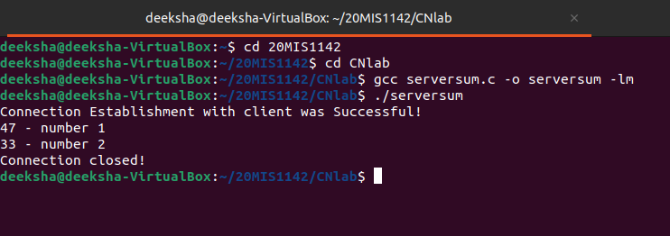
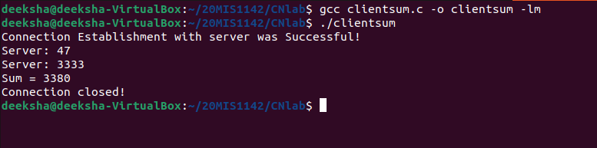

LAB05: Error detection and correction using hamming code
#include<stdio.h>

void main() {
int data[10];
int dataatrec[10],c,c1,c2,c3,i;

printf("Enter 4 bits of data one by one\n");
scanf("%d",&data[0]);
scanf("%d",&data[1]);
scanf("%d",&data[2]);
scanf("%d",&data[4]);

//Calculation of even parity
data[6]=data[0]^data[2]^data[4];
data[5]=data[0]^data[1]^data[4];
data[3]=data[0]^data[1]^data[2];

printf("\nEncoded data is\n");
for(i=0;i<7;i++)
printf("%d",data[i]);

printf("\n\nEnter received data bits one by one\n");
for(i=0;i<7;i++)
scanf("%d",&dataatrec[i]);

c1=dataatrec[6]^dataatrec[4]^dataatrec[2]^dataatrec[0];
c2=dataatrec[5]^dataatrec[4]^dataatrec[1]^dataatrec[0];
c3=dataatrec[3]^dataatrec[2]^dataatrec[1]^dataatrec[0];
c=c3*4+c2*2+c1 ;

if(c==0) {
printf("\nNo error while transmission of data\n");
}
else {
printf("\nError on position %d",c);

printf("\nData sent : ");
for(i=0;i<7;i++)
printf("%d",data[i]);

printf("\nData received : ");
for(i=0;i<7;i++)
printf("%d",dataatrec[i]);
printf("\nCorrect message is\n");

//if errorneous bit is 0 we complement it else vice versa
if(dataatrec[7-c]==0)
dataatrec[7-c]=1;
else
dataatrec[7-c]=0;
for (i=0;i<7;i++) {
printf("%d",dataatrec[i]);
}
}
}
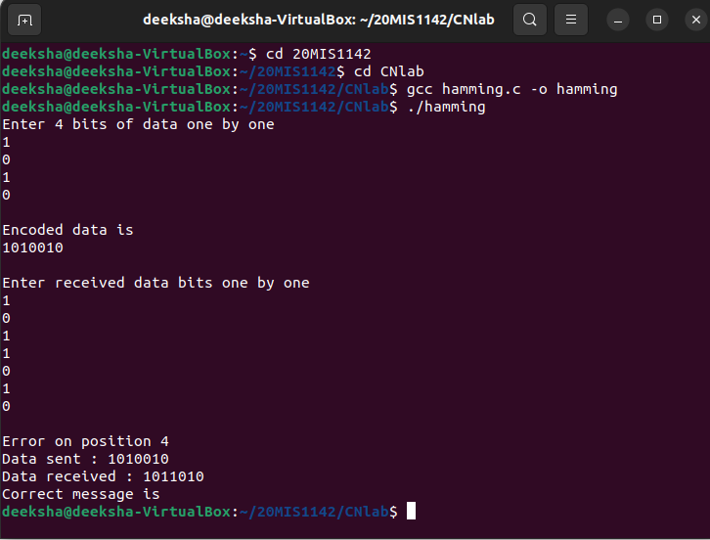

LAB06: CSMA/CD
#include<stdio.h>
#include<stdlib.h>
#include<pthread.h>
#include<string.h>
#include<sys/time.h>
int x=0;
void capture()
{
exit(0);
}
int get()
{
return x;
}
void put()
{
x++;
}
void node(char *p)
{
int name;
int seq1,seq2,i=0;
long int t;
struct timeval tv;
struct timezonetz;
name=atoi(p);
while(1)
{
seq1=get();
seq2=get();
if(seq1==seq2)
{
put();
seq1=get();
printf("station %d transmitting frame %d\n",name,++i);
sleep(3);
seq2=get();
if(seq1!=seq2)
{
printf("station %d collision occured %d \n",name,i--);
sleep(3);
}
else
{
printf("station %d complete\n",name,i);
}
}
sleep(3);
}
}
main()
{
pthread_t t1,t2,t3;
pthread_create(&t1,0,(void *)node,"1");
pthread_create(&t2,0,(void *)node,"2");
pthread_create(&t3,0,(void *)node,"3");
while(1);
}
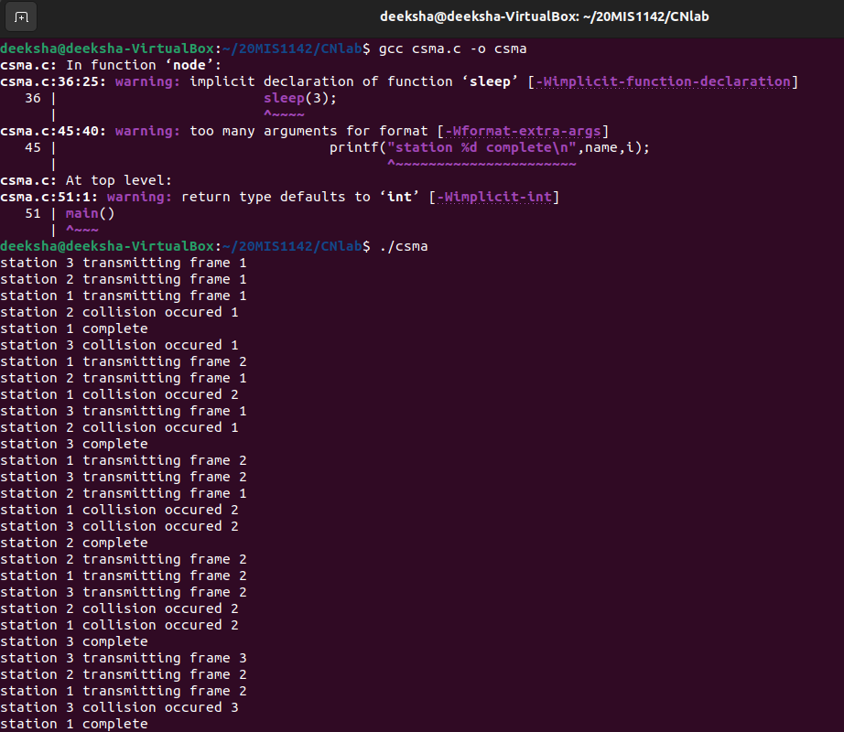
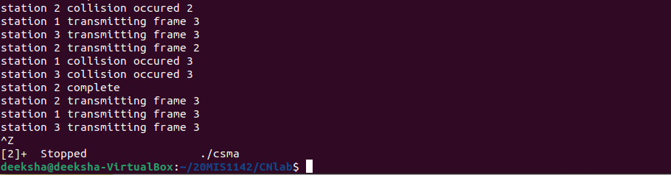

LAB07: Distance vecrtor:-
#include<stdio.h>
struct node
{
unsigned dist[20];
unsigned from[20];
}rt[10];
int main()
{
int dmat[20][20];
int n,i,j,k,count=0;
printf("\nEnter the number of nodes : ");
scanf("%d",&n);
printf("\nEnter the cost matrix :\n");
for(i=0;i<n;i++)
for(j=0;j<n;j++)
{
scanf("%d",&dmat[i][j]);
dmat[i][i]=0;
rt[i].dist[j]=dmat[i][j];
rt[i].from[j]=j;
}
do
{
count=0;
for(i=0;i<n;i++)
for(j=0;j<n;j++)
for(k=0;k<n;k++)
if(rt[i].dist[j]>dmat[i][k]+rt[k].dist[j])
{
rt[i].dist[j]=rt[i].dist[k]+rt[k].dist[j];
rt[i].from[j]=k;
count++;
}
}while(count!=0);
for(i=0;i<n;i++)
{
printf("\n\nState value for router %d is \n",i+1);
for(j=0;j<n;j++)
{
printf("\t\nnode %d via %d Distance%d",j+1,rt[i].from[j]+1,rt[i].dist[j]);
}
}
printf("\n\n");
}

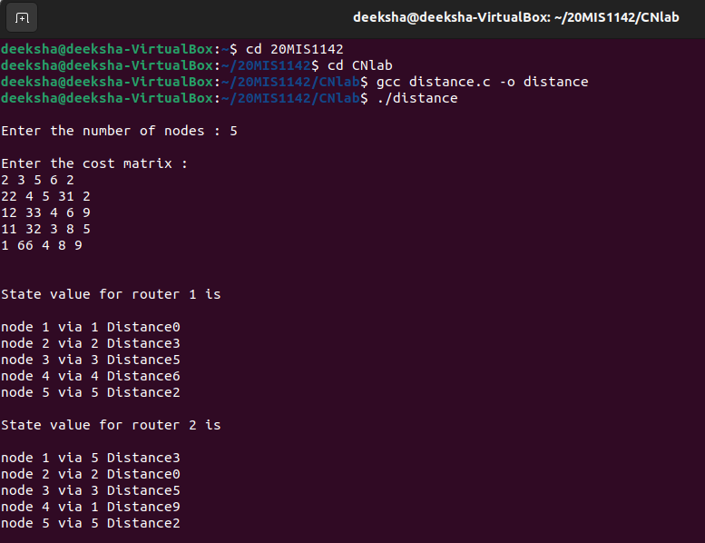
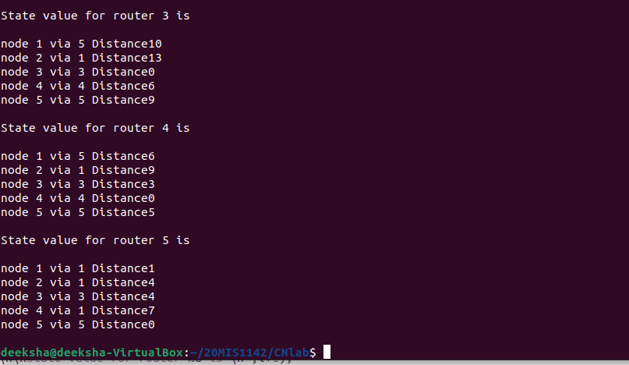

LAB08 : OSPF:-
#include <stdio.h>
#include <string.h>
int main()
{
int count,src_router,i,j,k,w,v,min;
int cost_matrix[100][100],dist[100],last[100];
int flag[100];
printf("\n Enter the no of routers");
scanf("%d",&count);
printf("\n Enter the cost matrix values:");
for(i=0;i<count;i++)
{
for(j=0;j<count;j++)
{
printf("\n%d->%d:",i,j);
scanf("%d",&cost_matrix[i][j]);
if(cost_matrix[i][j]<0)cost_matrix[i][j]=1000;
}
}
printf("\n Enter the source router:");
scanf("%d",&src_router);
for(v=0;v<count;v++)
{
flag[v]=0;
last[v]=src_router;
dist[v]=cost_matrix[src_router][v];
}
flag[src_router]=1;
for(i=0;i<count;i++)
{
min=1000;
for(w=0;w<count;w++)
{
if(!flag[w])
if(dist[w]<min)
{
v=w;
min=dist[w];
}
}
flag[v]=1;
for(w=0;w<count;w++)
{
if(!flag[w])
if(min+cost_matrix[v][w]<dist[w])
{
dist[w]=min+cost_matrix[v][w];
last[w]=v;
}
}
}
for(i=0;i<count;i++)
{
printf("\n%d==>%d:Path taken:%d",src_router,i,i);
w=i;
while(w!=src_router)
{
printf("\n<--%d",last[w]);w=last[w];
}
printf("\n Shortest path cost:%d",dist[i]);
}
}
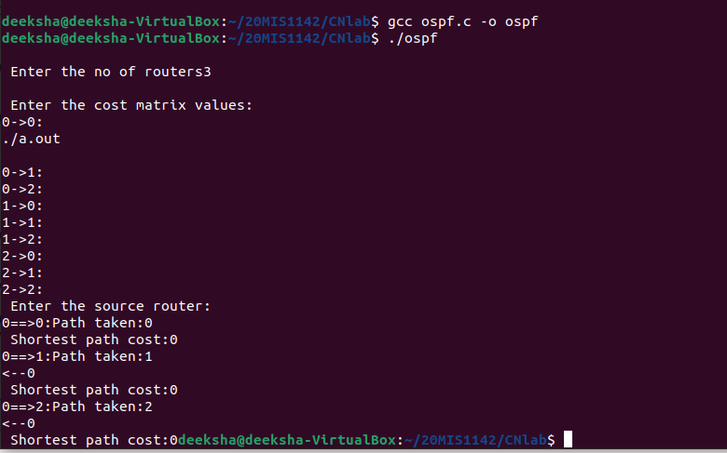

LAB09: CRC
#include<stdio.h>
char data[20],div[20],temp[4],total[100];
int i,j,datalen,divlen,len,flag=1;
void check();
int main()
{
printf("Enter the total bit of data:");
scanf("%d",&datalen);
printf("\nEnter the total bit of divisor:");
scanf("%d",&divlen);
len=datalen+divlen-1;
printf("\nEnter the data:");
scanf("%s",&data);
printf("\nEnter the divisor:");
scanf("%s",div);

for(i=0;i<datalen;i++)
{
total[i]=data[i];
temp[i]=data[i];
}
for(i=datalen;i<len;i++) //padded with zeroes corresponding to divlen
total[i]='0';
check(); // check for crc
for(i=0;i<divlen;i++) // append crc output (remainder) at end of temp
temp[i+datalen]=data[i];
printf("\ntransmitted Code Word:%s",temp);
printf("\n\nEnter the received code word:");
scanf("%s",total);
check();
for(i=0;i<divlen-1;i++)
if(data[i]=='1')
{
flag=0;
break;
}
if(flag==1)
printf("\nsuccessful!!");
else
printf("\nreceived code word contains errors...\n");
}
void check()
{
for(j=0;j<divlen;j++)
data[j]=total[j];
while(j<=len)
{
if(data[0]=='1') // in XOR ans remains as it is except in case of 1
for(i = 1;i <divlen ; i++)
data[i] = (( data[i] == div[i])?'0':'1');
for(i=0;i<divlen-1;i++) // left shift data word by 1 after div
data[i]=data[i+1];
data[i]=total[j++]; // replace empty right by total
}
}
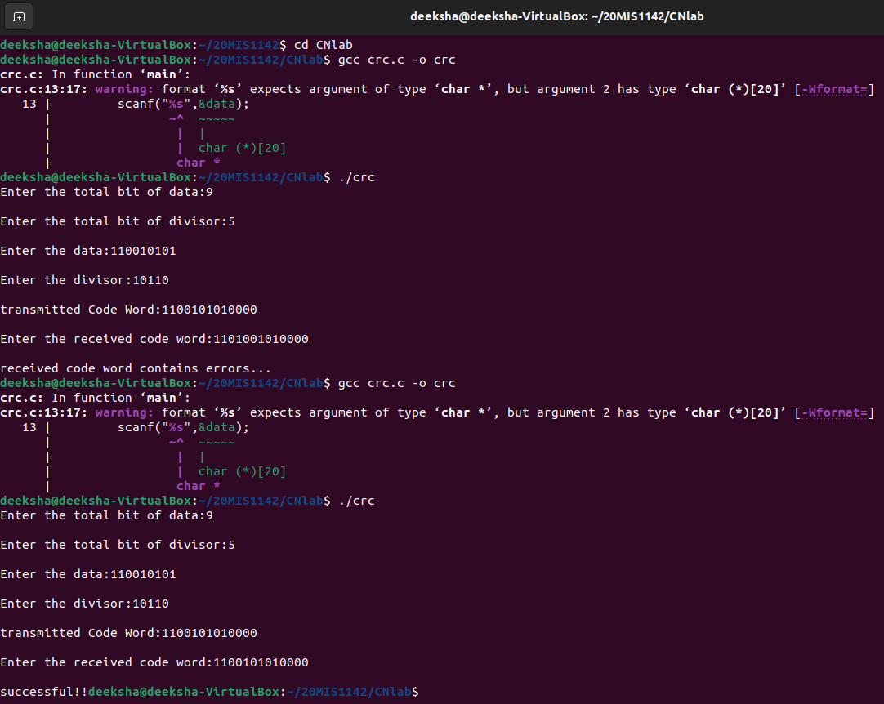

LAB10: Checksum
#include<stdio.h>
#include<string.h>

int main()
{
char a[20],b[20];
char sum[20],complement[20];
int i,length;

printf("Enter first binary string\n");
scanf("%s",&a);
printf("Enter second binary string\n");
scanf("%s",&b);

if(strlen(a)==strlen(b)){
length = strlen(a);
char carry='0';

for(i=length-1;i>=0;i--)
{
if(a[i]=='0' && b[i]=='0' && carry=='0')
{
sum[i]='0';
carry='0';
}
else if(a[i]=='0' && b[i]=='0' && carry=='1')
{
sum[i]='1';
carry='0';

}
else if(a[i]=='0' && b[i]=='1' && carry=='0')
{
sum[i]='1';
carry='0';

}
else if(a[i]=='0' && b[i]=='1' && carry=='1')
{
sum[i]='0';
carry='1';

}
else if(a[i]=='1' && b[i]=='0' && carry=='0')
{
sum[i]='1';
carry='0';

}
else if(a[i]=='1' && b[i]=='0' && carry=='1')
{
sum[i]='0';
carry='1';

}
else if(a[i]=='1' && b[i]=='1' && carry=='0')
{
sum[i]='0';
carry='1';

}
else if(a[i]=='1' && b[i]=='1' && carry=='1')
{
sum[i]='1';
carry='1';

}
else
break;
}

printf("\nSum=%c%s",carry,sum);
for(i=0;i<length;i++)
{
if(sum[i]=='0')
complement[i]='1';
else
complement[i]='0';
}

if(carry=='1')
carry='0';
else
carry='1';

printf("\nChecksum=%c%s",carry,complement);
}
else {
printf("\nWrong input strings");
}
}
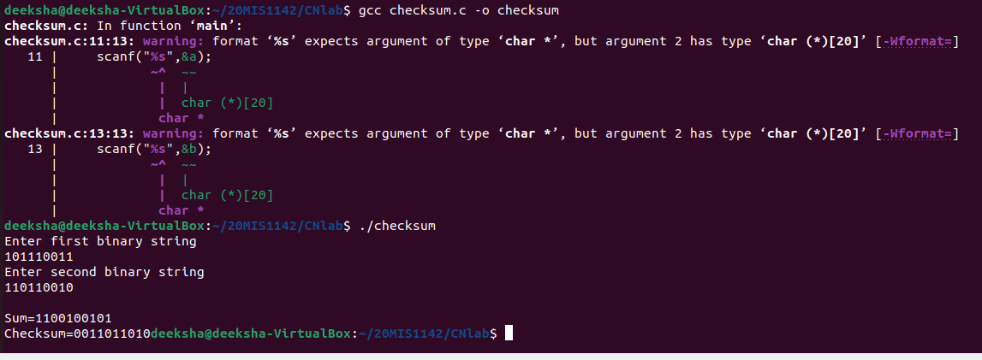

LAB11: SLIDING WINDOW PROTOCOL
#include<stdio.h>
int main()
{
int w,i,f,frames[50];
printf("Enter window size: ");
scanf("%d",&w);
printf("\nEnter number of frames to transmit: ");
scanf("%d",&f);
printf("\nEnter %d frames: ",f);
for(i=1;i<=f;i++)
scanf("%d",&frames[i]);
printf("\nWith sliding window protocol the frames will be sent in the following manner (assuming no corruption of frames)\n\n");
printf("After sending %d frames at each stage sender waits for acknowledgement sent by the receiver\n\n",w);

for(i=1;i<=f;i++)
{
if(i%w==0)
{
printf("%d\n",frames[i]);
printf("Acknowledgement of above frames sent is received by sender\n\n");
}
else
printf("%d ",frames[i]);
}
if(f%w!=0)
printf("\nAcknowledgement of above frames sent is received by sender\n");
return 0;
}
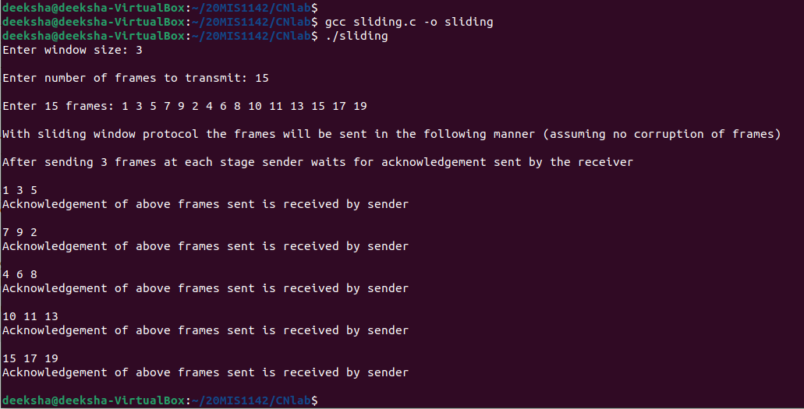

LAB 12. Socket Program for CRC
AIM:
To write a program for TCP connection establishment.
ALGORITHM:
SERVER:
STEP 1: Start
STEP 2: Declare the variables for the socket
STEP 3: Specify the family, protocol, IP address and port number
STEP 4: Create a socket using socket() function
STEP 5: Bind the IP address and Port number
STEP 6: Listen and accept the client’s request for the connection
STEP 7: Establish the connection with the client
STEP 8: Display the dividend and divisor
STEP 9: Display the dividend with zero appended
STEP 10: Display the quotient, remainder and CRC value
STEP 11: Close the socket
STEP 12: Stop
CLIENT:
STEP 1: Start
STEP 2: Declare the variables for the socket
STEP 3: Specify the family, protocol, IP address and port number
STEP 4: Create a socket using socket() function
STEP 5: Call the connect() function
STEP 6: Read the dividend and divisor
STEP 6: Display the quotient, remainder and CRC value
STEP 6: Close the socket
STEP 7: Stop

SOURCE CODE:
SERVER:
#include<stdio.h>
#include<string.h>
#include<sys/types.h>
#include<sys/socket.h>
#include<netinet/in.h>
#include<netdb.h>
#define SERV_TCP_PORT 5035
int main(int argc, char **argv)
{
int sockfd,newsockfd,clength;
struct sockaddr_inserv_addr,cli_addr;
char a[30],b[30],c[30]={0},q[30]={0},p[30]={0},np[30]={0},crc[10]={0},r[30]={0};
int n,m,i=0,j=0,count=0,k=0,l=0,ir=0,ip=0,cou=0,u=0,w=0,nk=0;
sockfd=socket(AF_INET,SOCK_STREAM,0);
serv_addr.sin_family=AF_INET;
serv_addr.sin_addr.s_addr=INADDR_ANY;
serv_addr.sin_port=htons(SERV_TCP_PORT);
printf("\n Binded...");
bind(sockfd,(struct sockaddr*)&serv_addr,sizeof(serv_addr));
listen(sockfd,5);
clength=sizeof(cli_addr);
newsockfd=accept(sockfd,(struct sockaddr*)&cli_addr,&clength);
read(newsockfd,a,30);
read(newsockfd,b,30);
m=strlen(b);
printf("\n Dividend:%s",a);
printf("\n Divisor:%s",b);
strcpy(c,a);
for(i=0;i<m-1;i++)
strcat(c,"0");
printf("\n Dividend with zero appended:%s",c);
for(i=0;i<m;i++)
{
p[k++]=c[i];
if(strlen(p)==m)
q[j++]='l';
}
for(i=0;i<strlen(c);)
{
if(p[nk++]==b[l++])
r[ir++]='0';
else
r[ir++]='l';
count++;
if(count==strlen(b)&&i<(strlen(c)-1))
{
ip=0;
for(u=0;u<strlen(b);u++)
{
if(r[u]=='l')
{
for(n=u;n<strlen(b);n++)
{
np[ip++]=r[n];
r[n]='0';
cou++;
}
}
}
count=0;
nk=0;
l=0;
ir=0;
if(cou!=strlen(b))
{
if((strlen(b)-cou)==(strlen(c)-(i+1))||(strlen(b)-cou)<(strlen(c)-(i+1)))
{
while(cou!=strlen(b))
{
i++;
np[ip++]=c[i];
cou++;
w++;
}
strcpy(p,np);
for(u=0;u<w-1;u++)
q[j++]='0';
if(w!=0)
{
i-=strlen(np);
w=0;
}
}
else
{
for(;i+1<strlen(c);)
{
i++;
np[ip++]=c[i];
w++;
}
if(ip<strlen(b))
{
for(;ip<strlen(b);)
np[ip++]=' ';
}
strcpy(r,np);
for(u=0;u<w-1;u++)
q[i++]='0';
i=strlen(c);
w=0;
}
}
if(cou=strlen(b))
{
q[j++]='l';
cou=0;
}
ip=0;
cou=0;
}
i++;
}
printf("\n Quotient=%s",q);
printf("\n Remainder=%s",r);
for(i=strlen(r)-(m-1);i<=strlen(r);i++)
crc[w++]=r[i];
printf("\n CRC values: %s\n",crc);
write(newsockfd,q,30);
write(newsockfd,r,30);
write(newsockfd,crc,10);
close(sockfd);
return 0;
}
CLIENT:
#include<stdio.h>
#include<string.h>
#include<sys/types.h>
#include<sys/socket.h>
#include<netinet/in.h>
#include<netdb.h>
#define SERV_TCP_PORT 5035
int main(int argc,char * * argv)
{
int sockfd;
struct sockaddr_inserv_addr;
struct hostent *server;
char a[30],b[30],q[30],r[30],crc[10];
sockfd=socket(AF_INET,SOCK_STREAM,0);
serv_addr.sin_family=AF_INET;
serv_addr.sin_addr.s_addr=inet_addr("127.0.0.1");
serv_addr.sin_port=htons(SERV_TCP_PORT);
connect(sockfd,(struct sockaddr*)&serv_addr,sizeof(serv_addr));
printf("\nEnter the dividend:");
scanf("%s",a);
printf("\nEnter the divisor:");
scanf("%s",b);
write(sockfd,a,30);
write(sockfd,b,30);
printf("\n");
printf("\nServer result:");
read(sockfd,q,30);
read(sockfd,r,30);
read(sockfd,crc,10);
printf("\n\nQuotient=%s",q);
printf("\n\nRemainder=%s",r);
printf("\n\nCRC values=%s\n",crc);
close(sockfd);
return 0;
}
OUTPUT:
SERVER:
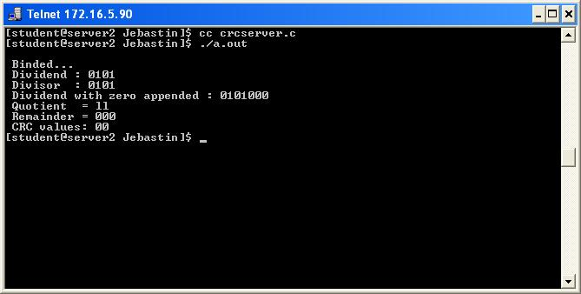
CLIENT:
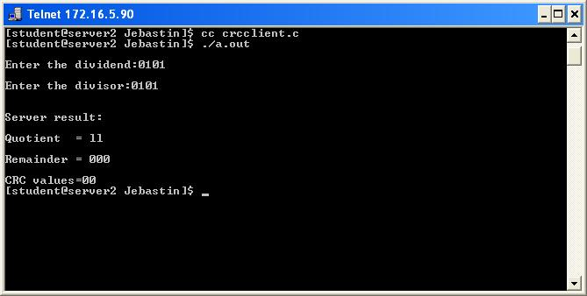

RESULT:
Thus the program for Cyclic Redundancy Check was executed and the output was
verified.

